  
**ACE Interface in Brief**



ACE Interface is a Limited Liability Corporation that provides products and services to people like you, who are committed to do everything necessary to accelerate the intergenerational changes that will improve health and quality of life. As originators of the science and community application of the ACE Study, **Dr. Robert Anda and Laura Porter** develop and disseminate educational products, provide assistance, consultation and analysis, design high-leverage strategies for improving health and well-being, and facilitate empowerment processes that invite everyone to contribute to ACE-informed innovations.

**If you are reading this web posting, you are a leader in the most important public health movement of our time – perhaps of all time**. The Adverse Childhood Experiences (ACE) Study findings represent a paradigm shift in human understanding of the origins of physical, social, mental, and societal health and well-being. We now know that leading causes of disease and disability, learning and productivity problems, and early death have their roots in the cumulative neurodevelopmental impacts of Adverse Childhood Experiences (ACEs).



The momentum around ACEs is stunning. Demand for presentations and education about the ACE concepts and their community applications has grown rapidly. Desire for education, solutions and partnership in this pioneering work is growing; and so is the **importance of providing accurate, timely, and actionable information to diverse audiences**. These facts are critical elements in the decision to form ACE Interface.

**ACE Interface provides a bridge** **and connecting point** for multiple disciplines and service sectors and diverse communities. An interdisciplinary staff with an array of experience in this field collaborates to develop products and services which focus on education about ACEs, developmental neurobiology, resilience and community empowerment.



**ACE Interface Products and Services**

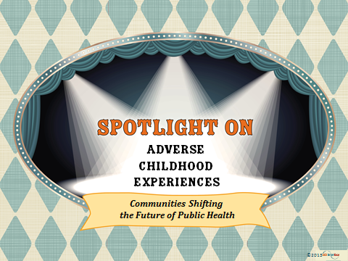

The products and services of ACE Interface are designed to have a multiplier effect that **disseminates knowledge and practices** rapidly and to a wide and diverse set of audiences.

**The ACE Interface Master Trainer Education Package** offers a **proven educational framework and strategy** for rapidly disseminating information about the ACE study, along with neurobiology that explains why ACEs have so much effect in people’s lives, and what we can all do to dramatically improve health and resilience for this and future generations. Master Trainers and the speakers they train can be deployed to all corners of a state and are qualified to maintain the fidelity of the science base and facilitate the expansion of interdisciplinary, multi-sector and community connections that lead to healthy and sustainable empowerment strategies and change. **Multiple states are already engaging our Master Trainer Education Package.**

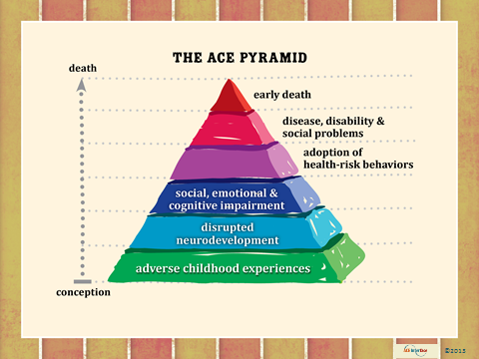

**Speaking and consultation services of ACE Interface include the following**: keynote presentations and coordinated workshops, documentation of ACE-informed practice and policy innovations, Think Tank hosting, data analysis and reports to support dialogue and policy discussion, assuring fidelity and quality of surveillance reports and other products, educational framing, community capacity development processes, innovative expansion of data collection and analysis to engage a wider array of interests and leadership, conference design and facilitation, coalition building, engaging in fundraising, aligning resources to achieve a greater impact, designing civic engagement strategies, use of visual art and other creative arts for community engagement, and ethnographic/culturally sensitive tailoring of materials.

